Dictated Sentences

What is a dictated sentence?
A dictated sentence is a sentence that you tell your child. Your child has to remember the sentence and write it down using the correct punctuation. All the dictated sentences on this document contain Year One Common Exception Words for your child to practise.

How to use dictated sentences:
Choose a sentence to use. Say the sentence a number of times with your child before they write it down (you could use different voices each time you say the sentence e.g. a whisper, a shout, a robot voice, like a mouse etc.) Once your child has remembered the sentence, ask them to write it down. Once they have written the sentence use this self check stick to check their work with them.
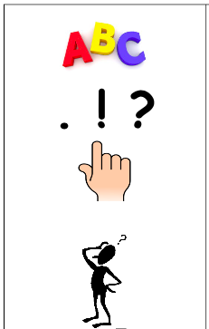
Has your child stated the sentence with a capital letter?
Have they used a capital letter for ‘I’?
When your child reads back over the sentence, does it make sense? Have they missed out any words?
Has your child ended the sentence with the correct punctuation? This could be a full stop, an explanation mark or a question mark.

Has your child used clear spaces in-between each word? We call these finger spaces.

We recommend choosing two sentences to do a day with your child. Here are some you can use:

- Our school is the best!
- Where are you going today?
- My friend put the brick on top of the tower.
- I love my big house by the sea.
- Once there was a dog called Mike.
- We went to the park with our friends.
- Here is the one that you want.
- You have to push the red button.
- Ask your mum if you can come and play today.
- Some of my friends said they love sweets.
- No one has a green or red pen.
- Do you want to come to tea today?
- She has a full glass of milk on the tray.
- It is raining outside so you need a coat.
- We were sleepy after a long day.
- She wants him to be her friend.
- He says they are his toys.
- Is his mum a vet?
- One day I went to the shop with my friend.
- Ask your friend if you can play with them.

