Devices which I might go online with:
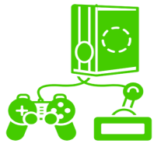
Phone Tablet Laptop Desktop Games Watch TV Home Hub

 | I will look after the devices that I am using and will follow the rules for keeping safe.
 | I will talk to an adult if I see something that I do not like. I will tell an adult if something pops up when I am using a device.
 | I will ask an adult if I am allowed on a new website or online game.
 | I know that it is important to play games which are suitable for my age.
 | I will think about how much time I spend on the computer because I know that it is important to also stay active.
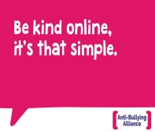 | Just like in real life, I will be kind when I am online.
 | I will not play games online with people that I do not know and I will not send them messages because these people are strangers.
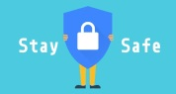 | I will not share personal information with people (full name, date of birth, address, phone number, where I go to school).
 | I am learning about the safety tools to block, report or flag up.

