Spelling Activity Ideas
You could spell:
Year One Common Exception Words
Year Two Common Exception Words
Numbers written as words to twenty (e.g. one, two, three etc)
Days of the Week
Months of the Year
The Seasons
Write your words playing noughts and crosses. | Write your words in all different colours. | Write your spelling words out with the vowels in red and the consonants in blue.  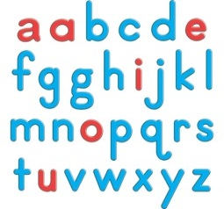 | Word Exercise  Spell out your spelling words while doing your favourite exercise.  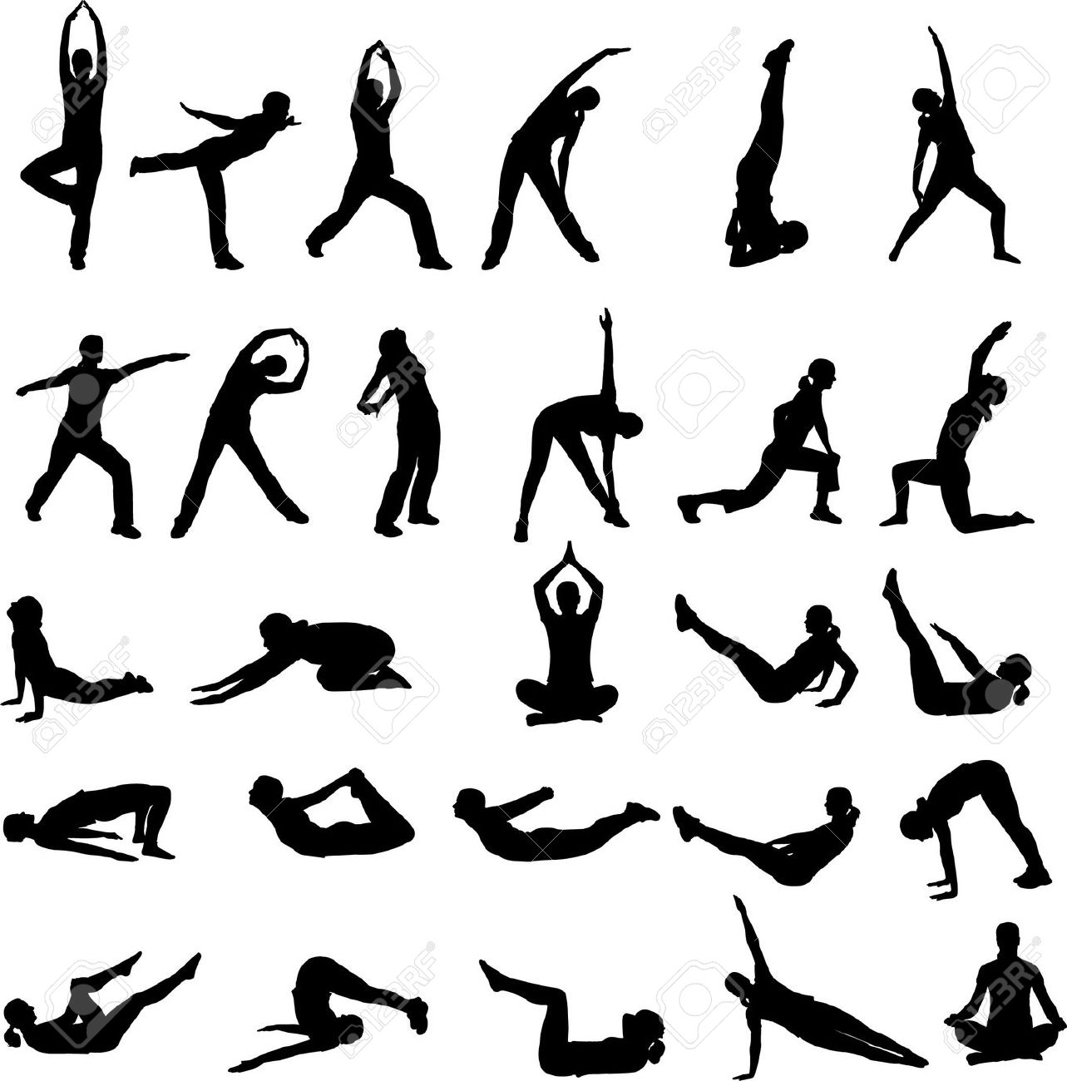
Write your words in a messy way. (Paint etc)  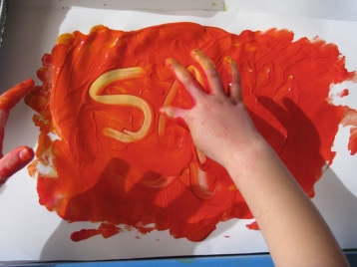 | Write each word 5 times. | Hide your words in a picture that you draw.  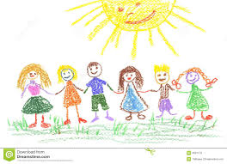 | Timer  Set a timer for three minutes. How many times can you write your words?  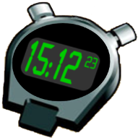
Put your spelling words in alphabetical order.  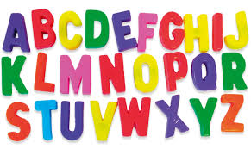 | Use different voices to spell out your words. | Write your words in ‘fancy’ writing like curly writing or bubble writing.  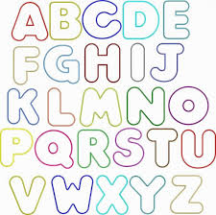 | Create a word search using your spelling words. Highlight your hidden spelling words.  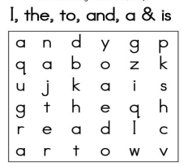
Use technology to type your spelling words. | Spend a couple of minutes singing the alphabet. | Draw some 2D shapes and write your spelling words in each shape. | Write your words three ways.  REALLY BIG  Really small  In your best handwriting
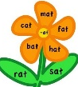  Spelling Flowers  Draw a picture of a great big flower.  Write each of you spelling words on  one of the flower petals or on a leaf. |  | Write two or three sentences with your spelling words.  I went to the shop.  You are my friend. | Can you find your spelling words in a story book?  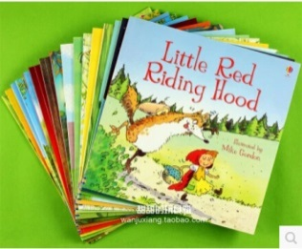
You could also make up your own way of practising your spelling words!

