Website information and useful online activities
Joe Wicks you tube channel @ 9 o’clock 20 mins daily exercise
https://www.storylineonline.net/ Online stories your child will love
https://www.topmarks.co.uk/maths-games/5-7-years/ maths games
http://www.snappymaths.com/ Maths worksheets for all topics
https://www.themathsfactor.com/subscribe/ Excellent lessons and activities currently free! You will need to subscribe first.
https://www.literacyshed.com/home.html Animations and videos that are great to inspire writing and a good opportunity to discuss storylines and characters. Please watch these first to ensure they appropriate for your child’s age.
https://www.phonicsplay.co.uk/# phonics play is now free Reception and Year 1. Also useful to recap for Year 2 children (phase 5 and 6)

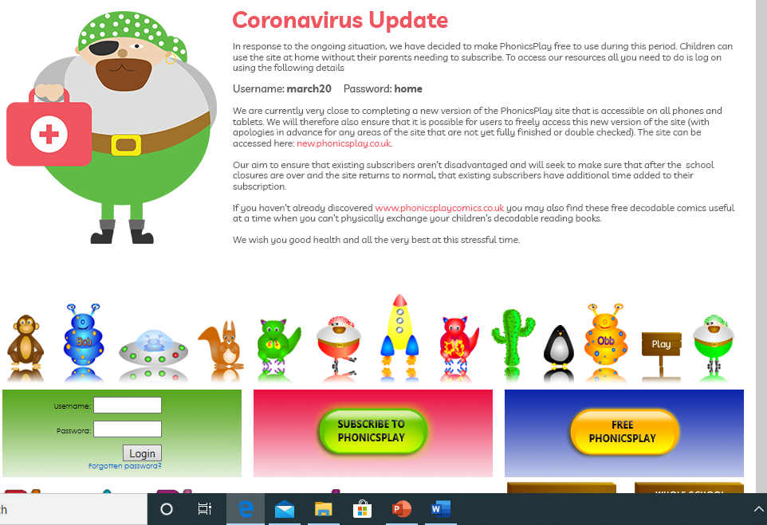
https://www.spellingplay.co.uk/ Year 2 spelling program. Go to ‘Enter site- planning units and resources- spelling planning units-interactive resources and printables.’
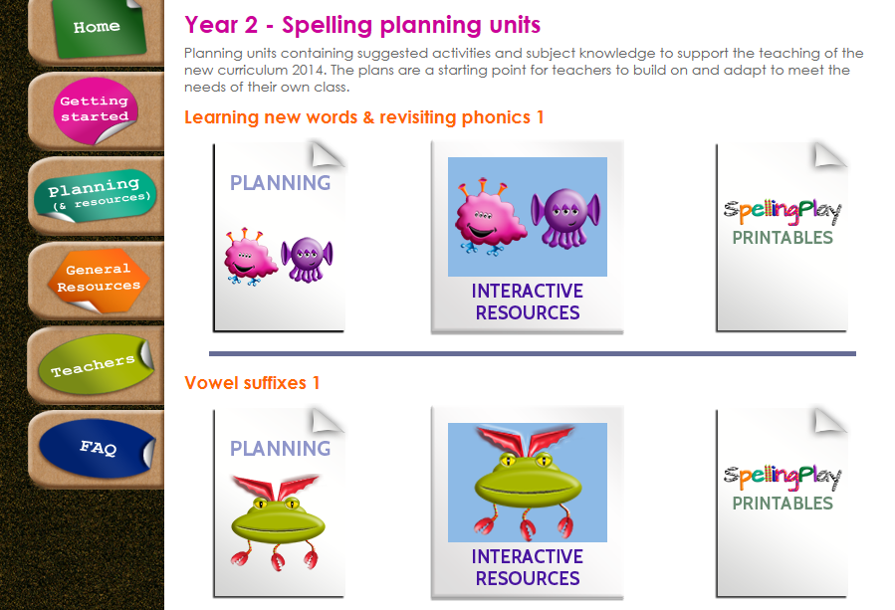
https://www.booktrust.org.uk/books-and-reading/have-some-fun/ All sorts of stories, quizzes, games, drawing tutorials and rhymes.
https://www.worldofdavidwalliams.com/ Some useful resources for more confident Year 2 children. Visit the link below for a free daily story everyday at 11.
https://www.worldofdavidwalliams.com/elevenses/
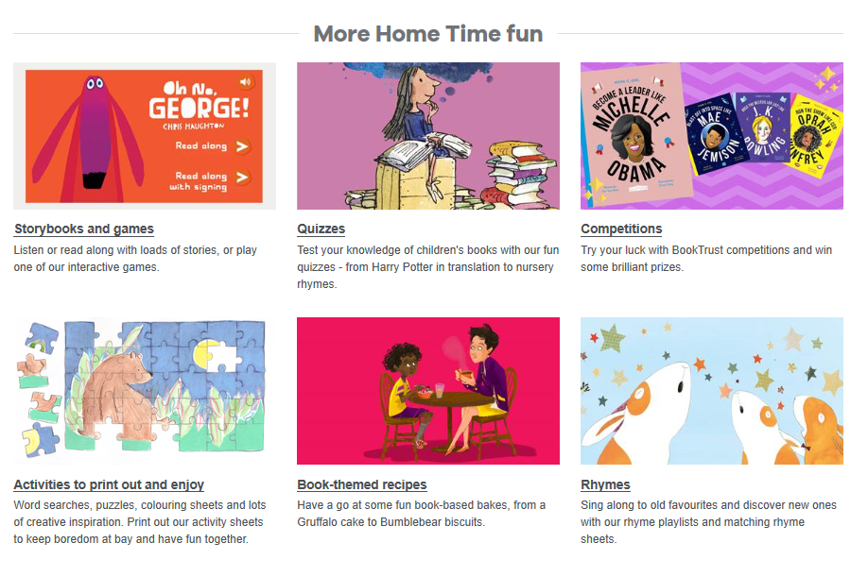
https://www.jamieoliver.com/features/simple-ideas-to-cook-with-kids/ recipes and advice on how to engage children with cooking.
real PE at home – online learning resources
real PE at home includes an online programme which supports families to be active, play and learn together. It includes a programme specifically for children in Early Years and Key Stage 1 with 12 themes, 6 areas, over 250 activities and challenges and 1000s of hours of fun and activity. This programme is great for family play and fun.
There are so many benefits to being active, not only to our physical wellbeing but also to our emotional and mental health, especially in such testing times for all of us. We hope that the ideas help support you and your family to stay fit and healthy in the coming months. Here are the details to access real PE at home:
The website address is: home.jasmineactive.com
Parent email: parent@suffieldpa-1.com
Password: suffieldpa

