Dictated Sentences set 2

What is a dictated sentence?
A dictated sentence is a sentence that you tell your child. Your child has to remember the sentence and write it down using the correct punctuation. All the dictated sentences in this document contain Year One Common Exception Words for your child to practise.

How to use dictated sentences:
Choose a sentence to use. Say the sentence a number of times with your child before they write it down (you could use different voices each time you say the sentence e.g. a whisper, a shout, a robot voice, like a mouse etc.) Once your child has remembered the sentence, ask them to write it down. Once they have written the sentence use this self check stick to check their work with them.
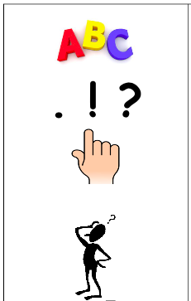
Has your child stated the sentence with a capital letter?
Have they used a capital letter for ‘I’?
When your child reads back over the sentence, does it make sense? Have they missed out any words?
Has your child ended the sentence with the correct punctuation? This could be a full stop, an explanation mark or a question mark.

Has your child used clear spaces in-between each word? We call these finger spaces.

We recommend choosing two sentences to do a day with your child. Here are some you can use:

- The boy was one today.
- They saw a pond with lots of fish in.
- Be a good friend.
- Do you like jam on toast?
- Once there was a cat called Sid.
- I put my red socks on.
- Has the postman been today?
- You have to push the green button.
- I love my new toy.
- Some of my friends said that they love films.
- I am full up.
- Do you want a drink?
- She has a full cup of milk on the stool.
- Put on your sun hat.
- Can you push me on the swing?
- She wants him to pull her up the big hill.
- The school has a big playground.
- Is his Dad a called Fred?
- Go and brush your teeth.
- I have so many jigsaws.

